FINAL REPORT · DATA ANALYSIS CAMP
MeridianHealth Retail & Supply Chain
Insights & Strategic Recommendations
Question answered: how can operational data from 12 pharmacy stores drive decisions that grow revenue, cut inventory waste, optimise staffing and deepen customer loyalty?

1. Executive summary
Metric | Value
Total revenue | $3.16M
Total profit | $1.11M
Weighted margin | 35.1%
Average discount | 12.6%
Transactions / average basket | 9,900 / $319.09
Active customers | 1,456 of 1,500 registered
Stock value at cost | $50.46M

Five findings matter most. Each is computed directly from the data model; where they differ from the project brief’s working hypotheses, section 6 shows how.
- Margin loss is concentrated in three stores. Wellness Corner, CuraMax Superstore and MediHealth Downtown earn 21% of revenue but only 12.7% of profit. Their margin is about 21% against 38.8% elsewhere, because they discount at 27.9% on average versus 7.5%.
- Vitamins & Supplements is the weakest category. Margin is 24.1% against 36.5% for the other eight categories. Discount depth is the same as everywhere else, so the cause is cost: products cost 67% of list price versus 55% in other categories.
- $10.64M of stock (21% of inventory value) is flagged expiry risk. 1,931 stock lines worth $9.60M are already past their expiry date and still hold units.
- Staffing data cannot yet support headcount decisions. 35 of 120 employees (29%) have a position/is_pharmacist mismatch, and two stores handle 45% of all prescriptions.
- Loyalty tiers show no spend uplift yet. Gold customers are 9.3% of active customers and 9.3% of revenue, with the lowest average basket of any tier.

2. Data and method
Source: the nine tables in the Power BI model (fact_sales 9,900 rows, fact_prescriptions 10,000, fact_stock 10,000, dim_customer 1,500, dim_product 5,000, dim_employee 120, dim_store 12, dim_category 9, dim_supplier 5). Sales and prescriptions cover 1 October 2024 to 9 December 2025; December 2025 is a partial month.
- Margin is weighted: SUM(profit) / SUM(total_amount). Average discount is the mean of discount_pct across sale lines.
- Expiry risk value is quantity × cost_price for stock lines with expiry_risk_flag = 1. “Already expired” means expiry_date before 1 October 2026 with quantity above zero.
- Staffing uses employee position to count pharmacists, with the is_pharmacist flag shown alongside because the two disagree.

3. The five business questions

Q1. Which stores are genuinely profitable after cost and discount?
Nine stores perform consistently: margins of 38.0–40.4% on average discounts of about 7.5%. Three stores sit far below them. Every one of the 2,461 sales discounted above 20% occurred in these three stores (their minimum discount is 22%; no other store exceeds 12%).
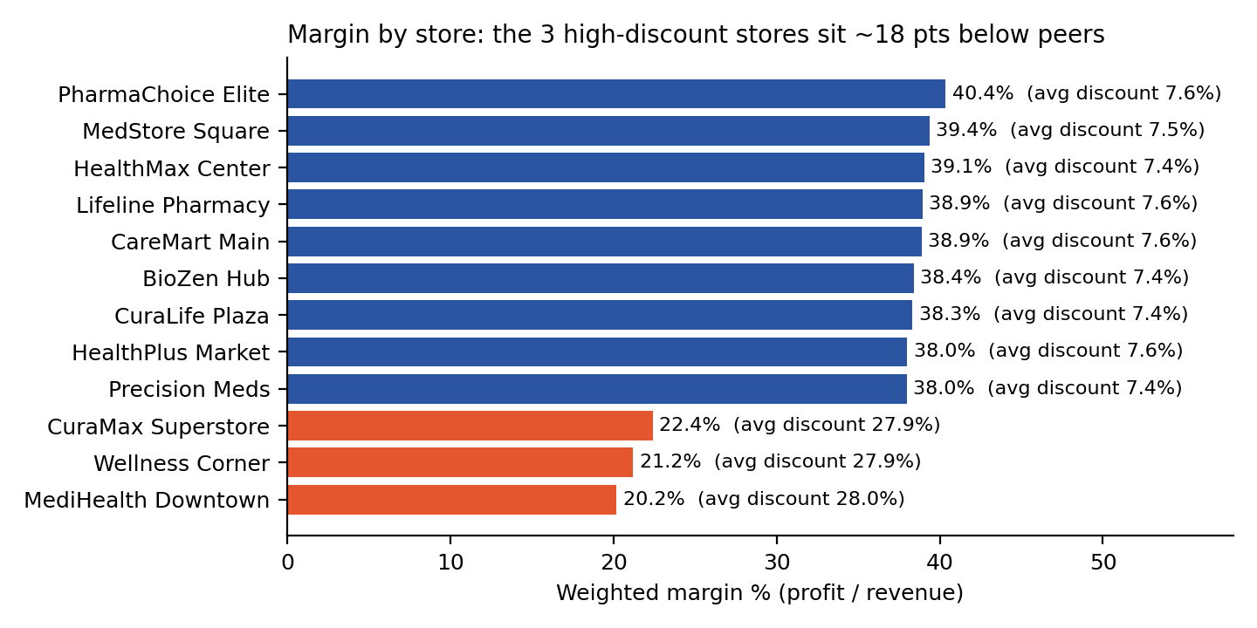
Store | City | Revenue | Margin | Avg discount
Precision Meds | Moncton | $314K | 38.0% | 7.4%
Lifeline Pharmacy | Halifax | $286K | 38.9% | 7.6%
HealthMax Center | Calgary | $285K | 39.1% | 7.4%
HealthPlus Market | Edmonton | $279K | 38.0% | 7.6%
MedStore Square | Quebec City | $271K | 39.4% | 7.5%
CuraLife Plaza | Vancouver | $271K | 38.3% | 7.4%
CareMart Main | Ottawa | $270K | 38.9% | 7.6%
BioZen Hub | Montreal | $267K | 38.4% | 7.4%
PharmaChoice Elite | Winnipeg | $254K | 40.4% | 7.6%
Wellness Corner | Waterloo | $229K | 21.2% | 27.9%
CuraMax Superstore | Regina | $218K | 22.4% | 27.9%
MediHealth Downtown | Toronto | $215K | 20.2% | 28.0%
Highlighted rows: the three high-discount stores. Together they hold 20.9% of revenue and 12.7% of profit.
If these three stores earned the peer-average 38.8% margin, profit would be about $116K higher, roughly 10% of total profit. This is an upper bound, since cutting discounts will cost some volume.

Q2. Which categories drive revenue, and which are over-discounted?
Revenue is evenly spread: every category holds 9.9–11.7% of revenue, so no single category dominates. Average discount is also flat across categories (12.3–13.0%), so discounting is a store problem, not a category problem. The real outlier is Vitamins & Supplements on margin.
Category | Revenue share | Margin | Avg discount
Vitamins & Supplements | 11.3% | 24.1% | 12.5%
Diagnostics | 11.6% | 34.2% | 12.3%
Personal Care | 11.7% | 35.4% | 12.7%
Prescription Drugs | 11.6% | 35.9% | 12.9%
First Aid | 9.9% | 36.4% | 12.4%
OTC Pain Relief | 10.8% | 36.7% | 12.4%
Baby & Child Care | 11.3% | 37.5% | 12.5%
Medical Devices | 10.9% | 37.6% | 13.0%
Skin & Derma Care | 11.0% | 38.7% | 12.4%

- Vitamins cost structure. Cost is 67% of list price versus 55% for other categories, across all five suppliers. In the nine normal stores Vitamins earns 29.0% margin; in the three high-discount stores it earns 4.1%.
- Discounting destroys margin. 609 sales (6.2%) were sold below cost, a combined loss of $57K. The share of loss-making sales rises from 4.8% at discounts up to 5% to 17.5% at discounts of 30–35%.

Q3. How much inventory value is at expiry risk?
2,093 stock lines (20.9%) are flagged as expiry risk, valued at $10.64M at cost, 21% of the $50.46M inventory. Value is spread across all categories, led by Baby & Child Care and Vitamins & Supplements; Prescription Drugs ranks fourth.
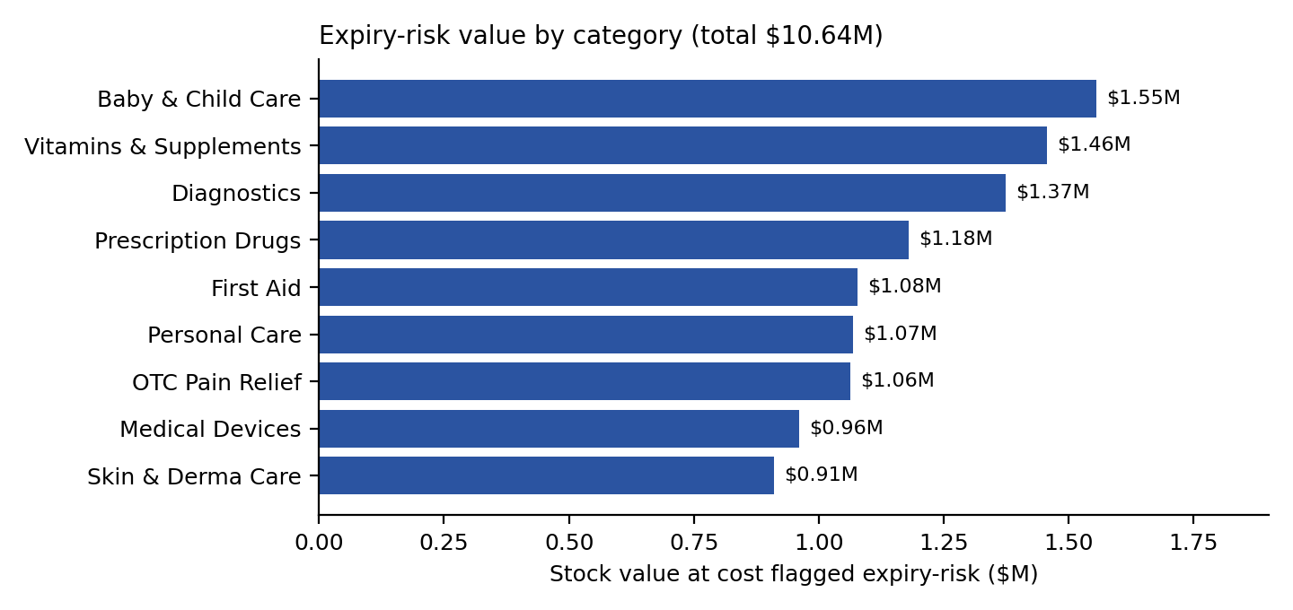
Indicator | Lines | Value at cost
Flagged expiry risk (expiry_risk_flag = 1) | 2,093 | $10.64M
Already past expiry date, still holding stock | 1,931 | $9.60M
Expiring within the next 30 days | 420 | $2.84M
Below reorder level (quantity ≤ reorder_level) | 3,173 | n/a
of which flagged below_reorder_flag = 1 | 2,128 | n/a
As-of date 1 October 2026. Confirm the stock snapshot date with the business before acting on the expired figures.
Two points deserve attention. First, most flagged stock is not “near” expiry but already expired, which is a patient-safety and compliance question as well as a financial one. Second, the below_reorder_flag understates need: 1,045 lines (33%) are at or under reorder level but unflagged. CareMart Main holds the highest risk value of any store ($1.04M).

Q4. Is pharmacist staffing aligned with prescription workload?
It cannot be answered reliably yet. Prescription volume is very uneven: CuraLife Plaza (2,244) and Lifeline Pharmacy (2,226) each handle about four times the volume of any other store (525–584), together 44.7% of all prescriptions. At the same time the pharmacist data is unreliable: 35 employees have conflicting position and flag values (14 pharmacists flagged 0; 21 non-pharmacists flagged 1), including employee 97.
Store | Staff | Pharm. (position) | Pharm. (flag) | Mismatches | Prescriptions | Rx per pharmacist
CuraLife Plaza | 18 | 3 | 4 | 5 | 2,244 | 748
Lifeline Pharmacy | 10 | 2 | 2 | 4 | 2,226 | 1,113
BioZen Hub | 6 | 0 | 1 | 1 | 584 | n/a
MediHealth Downtown | 15 | 2 | 6 | 6 | 583 | 292
MedStore Square | 8 | 0 | 3 | 3 | 569 | n/a
CareMart Main | 9 | 3 | 0 | 3 | 561 | 187
HealthMax Center | 6 | 3 | 2 | 1 | 551 | 184
Precision Meds | 7 | 1 | 2 | 3 | 551 | 551
HealthPlus Market | 9 | 1 | 4 | 3 | 543 | 543
PharmaChoice Elite | 13 | 2 | 2 | 2 | 538 | 269
CuraMax Superstore | 13 | 2 | 1 | 3 | 525 | 262
Wellness Corner | 6 | 1 | 0 | 1 | 525 | 525
Rx per pharmacist uses position. BioZen Hub and MedStore Square have no employee with position Pharmacist but still dispense 584 and 569 prescriptions. Among stores with a pharmacist, the ratio ranges from 184 to 1,113 (about 6×).
Provisionally, Lifeline Pharmacy (1,113 per pharmacist) and CuraLife Plaza (748) look most stretched, but this should be confirmed after the employee records are corrected.

Q5. Which customer segments and payment channels generate the most value?
Payment channels are broadly equal in value. Cards generate 61.8% of revenue; cash 21.8% and online 16.5%. Average basket ranges only from $312 (cash) to $327 (debit), a spread under 5%.
Payment method | Revenue | Share | Avg basket | Margin
Credit Card | $1,050K | 33.3% | $319.55 | 35.3%
Debit Card | $902K | 28.5% | $326.93 | 34.4%
Cash | $687K | 21.8% | $312.34 | 35.6%
Online | $520K | 16.5% | $314.06 | 35.3%

Loyalty tiers do not separate customers by value. Revenue per active customer is within about 8% across tiers ($2,112–$2,278), and Gold has the lowest average basket ($303). 70.6% of registered customers (1,059) have no tier. Repeat purchasing is near-universal (1,313 of 1,456 active customers bought more than once, 98.7% of revenue), so “repeat customer” does not discriminate and should not be used as a loyalty KPI.
Tier | Registered | Active | Revenue share | Revenue / active customer | Avg basket
Normal (no tier) | 1,059 | 1,025 | 70.2% | $2,162 | $317.93
Silver | 155 | 150 | 10.8% | $2,278 | $337.99
Gold | 139 | 136 | 9.3% | $2,167 | $302.63
Platinum | 147 | 145 | 9.7% | $2,112 | $324.36

4. Data quality and validation summary
Rule | Result | Severity
Foreign keys: sales → product / store / employee / customer; prescriptions → customer / product; stock → product | 100% match, 0 orphans | PASS
Discount above 50% policy ceiling | 0 rows (maximum 34%) | PASS
Margin above 80%; negative quantities; exact duplicate sales rows | 0 rows | PASS
Margin below 0 (sold below cost) | 609 sales, $57K loss | WARN
Pharmacist flag mismatch (position vs is_pharmacist) | 35 employees | ERROR
Expired stock still held (expiry_date < 1 Oct 2026, quantity > 0) | 1,931 lines | ERROR
Stock flag inconsistency (quantity ≤ reorder_level, below_reorder_flag = 0) | 1,045 lines | WARN
Duplicated title in doctor_name (“Dr. Dr.”) | 2,006 prescriptions | WARN
Loyalty tier blank | 1,059 customers (treated as Normal) | INFO

5. Strategic recommendations
R1. Reset discount authority in the three high-discount stores. No other store discounts above 12%. Cap discounts at a chain-wide ceiling of about 15% (the current 50% ceiling never binds) and review promotion approvals at Wellness Corner, CuraMax Superstore and MediHealth Downtown. Indicative upside: up to about $116K profit (10% of total).
R2. Fix Vitamins & Supplements economics. Renegotiate supplier cost or reprice, since cost is 67% of list versus 55% elsewhere, and stop discounting Vitamins in the three stores where margin is 4.1%. Indicative upside: about $44K if margin reached the 36.5% of other categories (partly overlaps R1).
R3. Act on expiry in two tiers. For the 420 lines ($2.84M) expiring within 30 days: inter-store transfer, supplier return and targeted markdown. For the 1,931 lines ($9.60M) already expired: remove from sale immediately, claim supplier credit or dispose in line with regulation, and reconcile stock records. Also fix the reorder flag logic (1,045 unflagged lines).
R4. Run a data-quality sprint on dim_employee before any staffing decision. Correct the 35 mismatches, then re-run prescriptions per pharmacist. Validate the prescription volume at CuraLife Plaza and Lifeline Pharmacy, and check why BioZen Hub and MedStore Square show no pharmacist.
R5. Hold further loyalty investment until it shows uplift. Redesign tier benefits, target the 70.6% of customers without a tier, and measure revenue per customer by tier against the current baseline of about $2,160.

6. Project-brief hypotheses versus the evidence
Brief’s working hypothesis | What the data shows
At least two stores run below 5% margin | Not supported. The lowest store margin is 20.2%; three stores sit at 20–22% because of heavy discounting.
Vitamins & Baby Care carry the highest discounts and weak returns | Partly. Discounts are flat (12.3–13.0%). Vitamins has weak margin due to cost; Baby & Child Care margin (37.5%) is above average.
Expiry risk concentrated in Pharmaceuticals and Vitamins | Partly. Vitamins ranks second; Baby & Child Care is first; Prescription Drugs is fourth.
Prescription volume varies about 3×; flag mismatches exist | Supported and larger: about 4.3× in volume, 6× per pharmacist, 35 mismatched employees.
Gold customers punch above their weight; card customers have higher baskets | Not supported. Gold share of customers equals its share of revenue. Debit and credit baskets are 2–5% above cash; online is similar to cash.

7. Limitations and next steps
- The data window is 14 months and December 2025 is partial, so year-over-year comparisons are valid only for October–December. A monthly trend should use a Year-Month axis; grouping by month name alone double-counts October–December and creates an artificial spike.
- Profit-uplift figures are indicative and ignore volume response to price or discount changes.
- Expiry figures depend on the assumed as-of date and stock snapshot date.
- The dataset is designed for relative comparison; do not quote the numbers as real-world benchmarks.

